Curriculum Vitae

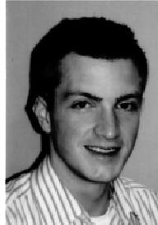
Christian-Hendrik Heeger

University of Lübeck
Medizinische Klinik II
Molekulargenetisches Labor 1
Ratzeburger Alle 160
23538 Lübeck

born at 01/05 in 1982

e-mail: Christian.Heeger@gmx.net
phone: 0049 451 – 500 6458

Education

06/04 – 06/06 | Semmelweis University of Budapest - Human medicine -
since 10/2006 | University of Lübeck - Human medicine -

Research Experience/Academic Appointments

02/2007 – today | Doktorand

